LAPORAN PRAKTIKUM
APLIKASI BERBASIS PLATFORM

MODUL 5
BOOTSTRAP


Disusun oleh:
IBNU RIZAL MUTAQIM
2311102067
S1 IF-06

Dosen Pengampu:
Dedy Agung Prabowo, S.Kom., M.Kom

PROGRAM STUDI S1 TEKNIK INFORMATIKA
FAKULTAS DIREKTORAT KAMPUS PURWOKERTO
UNIVERSITAS TELKOM
2026
LINK GIT : https://github.com/IbnuRizalll/Praktikum_ABP

MODUL 5
BOOTSTRAP
- Tugas Modul 5 – Bootstrap Installasi sampai membuat form
  - Source Code
- <!doctype html>
- <html lang="id">
- <head>
- <meta charset="UTF-8" />
- <meta name="viewport" content="width=device-width, initial-scale=1.0" />
- <title>Tugas Bootstrap</title>

- <!-- ================== 1. BOOTSTRAP CDN ================== -->
- <!-- CSS -->
- <link
- href="https://cdn.jsdelivr.net/npm/bootstrap@5.3.0/dist/css/bootstrap.min.css"
- rel="stylesheet"
- />

- <!-- jQuery (opsional untuk Bootstrap 5, tapi tetap boleh) -->
- <script src="https://code.jquery.com/jquery-3.7.0.min.js"></script>

- <!-- JS Bootstrap -->
- <script src="https://cdn.jsdelivr.net/npm/bootstrap@5.3.0/dist/js/bootstrap.bundle.min.js"></script>
- </head>

- <body class="p-4">
- <h1 class="text-center mb-5">Tugas Modul 5 - Bootstrap</h1>

- <!-- ================== 2. BOOTSTRAP GRID ================== -->
- <div class="container mb-5">
- <h3 class="mb-3">2. Bootstrap Grid</h3>

- <div class="row">
- <div class="col-12 col-md-8 bg-primary text-white p-3">
- .col-12 .col-md-8
- </div>
- <div class="col-6 col-md-4 bg-success text-white p-3">
- .col-6 .col-md-4
- </div>
- </div>

- <div class="row mt-2">
- <div class="col-6 col-md-4 bg-warning p-3">.col-6 .col-md-4</div>
- <div class="col-6 col-md-4 bg-danger text-white p-3">
- .col-6 .col-md-4
- </div>
- <div class="col-6 col-md-4 bg-info p-3">.col-6 .col-md-4</div>
- </div>

- <div class="row mt-2">
- <div class="col-6 bg-dark text-white p-3">.col-6</div>
- <div class="col-6 bg-secondary text-white p-3">.col-6</div>
- </div>
- </div>

- <!-- ================== 3. BOOTSTRAP TABLE ================== -->
- <div class="container mb-5">
- <h3 class="mb-3">3. Bootstrap Table</h3>

- <table class="table table-hover table-bordered">
- <thead class="table-dark">
- <tr>
- <th>#</th>
- <th>Nama Lengkap</th>
- <th>Asal Kota</th>
- <th>Umur</th>
- </tr>
- </thead>
- <tbody>
- <tr>
- <th>1</th>
- <td>Budi Rojadi</td>
- <td>Semarang</td>
- <td>35 th</td>
- </tr>
- <tr>
- <th>2</th>
- <td>Yulia Santi</td>
- <td>Bekasi</td>
- <td>32</td>
- </tr>
- <tr>
- <th>3</th>
- <td>Fahri Abdilah</td>
- <td>Medan</td>
- <td>38 th</td>
- </tr>
- </tbody>
- </table>
- </div>

- <!-- ================== 4. BOOTSTRAP IMAGE ================== -->
- <div class="container mb-5">
- <h3 class="mb-3">4. Bootstrap Image</h3>

- <h5>Thumbnail</h5>
- <img
- src="ibnu.jpg"
- class="img-thumbnail mb-3"
- alt="Thumbnail"
- width="300"
- />

- <h5>Responsive Image</h5>
- <img src="ibnu.jpg" class="img-fluid" alt="Responsive image" />
- </div>

- <!-- ================== 5. BOOTSTRAP BUTTON ================== -->
- <div class="container mb-5">
- <h3 class="mb-3">5. Bootstrap Button</h3>

- <button class="btn btn-secondary">Secondary</button>
- <button class="btn btn-primary btn-lg">Primary</button>
- <button class="btn btn-success w-100 my-2">Success</button>
- <button class="btn btn-info btn-sm">Info</button>
- <button class="btn btn-warning">Warning</button>
- <button class="btn btn-danger">Danger</button>
- <button class="btn btn-link">Link</button>
- </div>

- <!-- ================== 6. BOOTSTRAP FORM ================== -->
- <div class="container mb-5">
- <h3 class="mb-3">6. Bootstrap Form</h3>

- <form action="/action_page.php">
- <div class="row mb-3">
- <label class="col-sm-2 col-form-label">Username:</label>
- <div class="col-sm-10">
- <input
- type="text"
- class="form-control"
- placeholder="Enter username"
- />
- </div>
- </div>

- <div class="row mb-3">
- <label class="col-sm-2 col-form-label">Password:</label>
- <div class="col-sm-10">
- <input
- type="password"
- class="form-control"
- placeholder="Enter password"
- />
- </div>
- </div>

- <div class="row">
- <div class="col-sm-10 offset-sm-2">
- <button class="btn btn-success">Submit</button>
- </div>
- </div>
- </form>
- </div>
- </body>
- </html>

b. Screenshot output
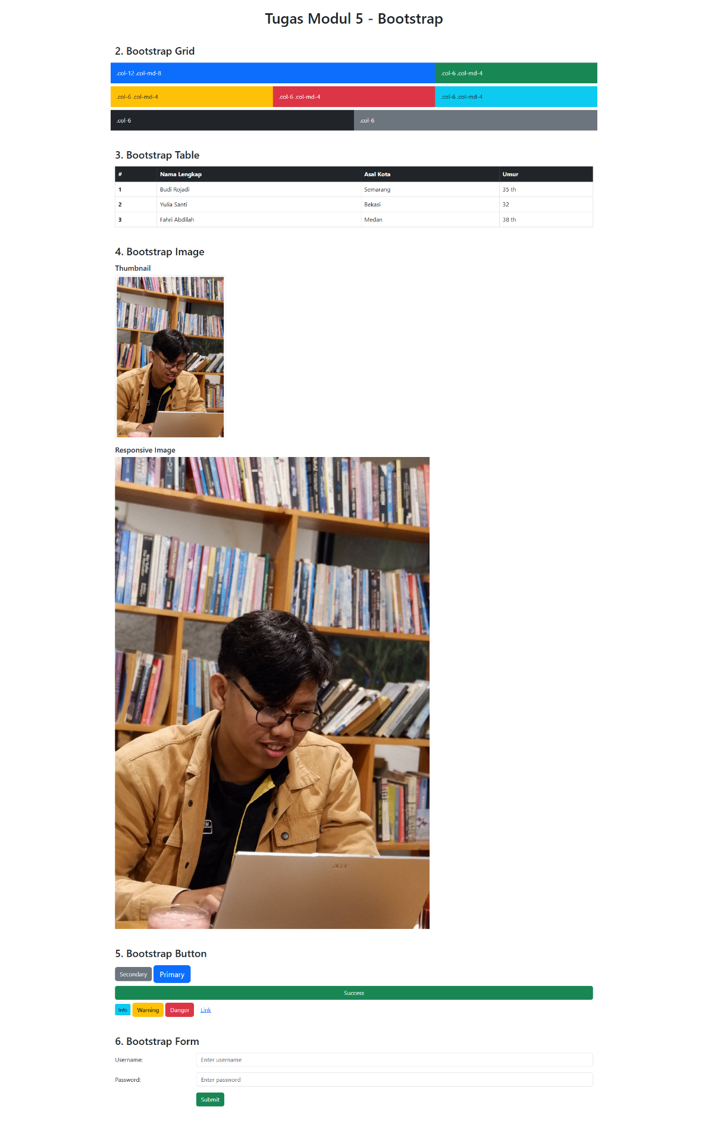
- Penjelasan dari code dan output (korelasi)
1. Bootstrap CDN
Kode menggunakan CDN untuk menghubungkan Bootstrap CSS dan JavaScript tanpa instalasi manual. Outputnya adalah halaman langsung memiliki styling Bootstrap seperti layout rapi dan responsif.

2. Bootstrap Grid
Menggunakan sistem grid (row dan col) untuk membagi layout menjadi beberapa kolom. Outputnya berupa susunan kotak yang menyesuaikan ukuran layar (responsif).

3. Bootstrap Table
Menggunakan class table dan table-hover untuk menampilkan data dalam bentuk tabel. Outputnya tabel terlihat rapi dan memiliki efek hover saat kursor diarahkan.

4. Bootstrap Image
Menggunakan img-thumbnail dan img-fluid. Outputnya gambar memiliki bingkai (thumbnail) dan bisa menyesuaikan ukuran layar (responsif).

5. Bootstrap Button
Menggunakan berbagai class tombol seperti btn-primary, btn-success, dll. Outputnya tombol tampil dengan warna dan ukuran berbeda sesuai fungsi.

6. Bootstrap Form
Menggunakan form dengan class form-control dan grid layout. Outputnya form terlihat rapi, sejajar, dan mudah digunakan.

